Wastesavers bin, box and caddy specifications – kerbside and flats recycling for Newport 2012

Residents of Houses:
- 55 litre blue and green recycling boxes (x2) for the collection of paper, plastic bottles, cans, glass bottles, textiles, mobile phones and toner cartridges, textiles, thin white card and small electrical items.
- 27 litre external brown caddy and 5 litre internal brown caddy for food waste collections
Residents of Flats
- 5 x 360 litre, for the collection of paper, glass bottles, cans, plastic bottles, cardboard and 1 x 240 litre recycling bin for the collection of food waste. These can be secured to the ground with locking posts if the site requires.
- 5 litre internal brown caddy for food waste collections

55l Ergo Kerbside Box (x2)
Capacity  (litres) | Width  (mm) | Depth  (mm) | Height  (mm)
55 | 585 | 390 | 350
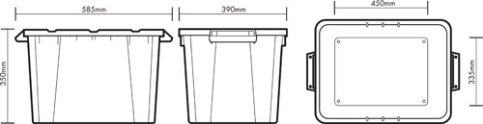

5l Food Waste Caddy
Capacity  (litres) | Width  (mm) | Depth  (mm) | Height  (mm)
5 | 250 | 205 | 205
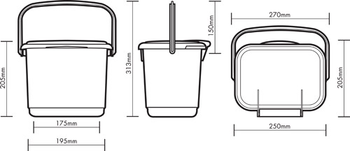

23l Food Waste Caddy
Capacity  (litres) | Width  (mm) | Depth  (mm) | Height  (mm)
23 | 320 | 400 | 405
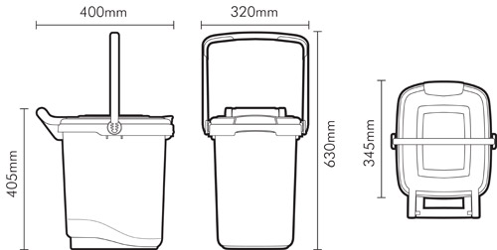

240 litre, 360 litre and 660 litre wheeled bins
Capacity  (litres) | Width  (mm) | Depth  (mm) | Height  (mm)
240 | 575 | 730 | 1060
360 | 580 | 875 | 1080
660 | 1360 | 780 | 1190
